**Saint Brigid Saint John the Baptist**

26th Sunday in

Ordinary Time

September 30, 2018

**Catholic Church Catholic Church**

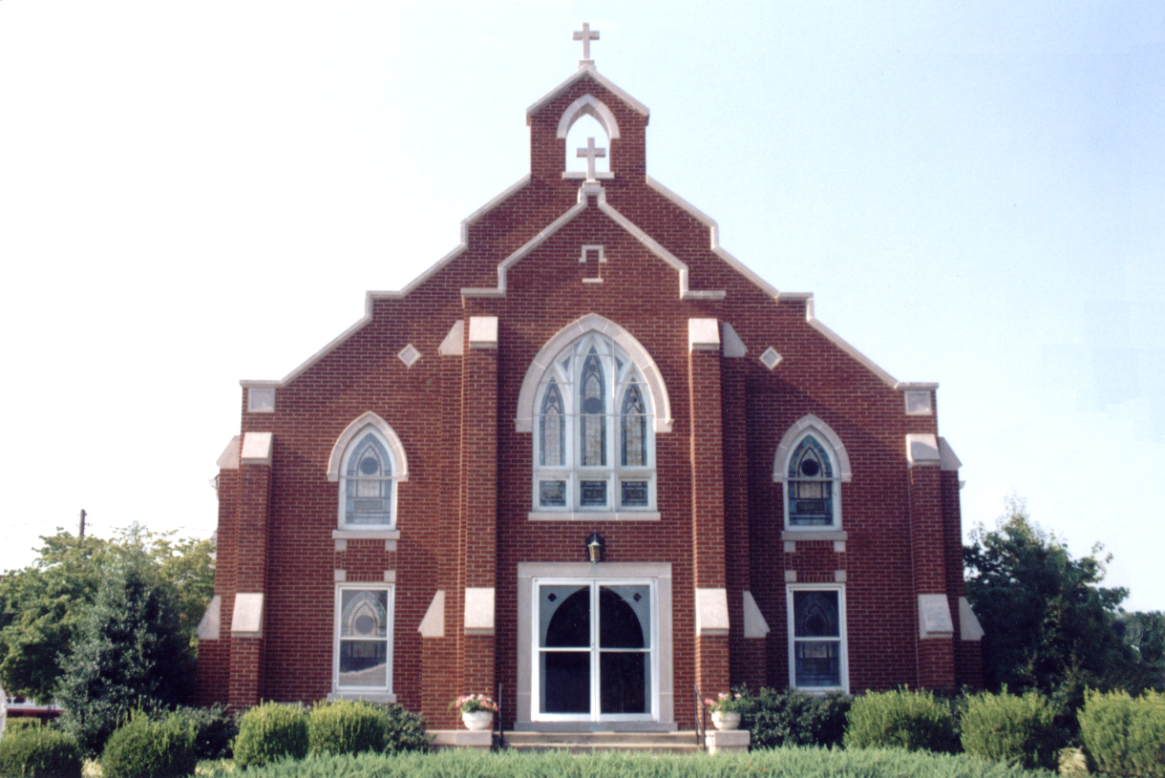

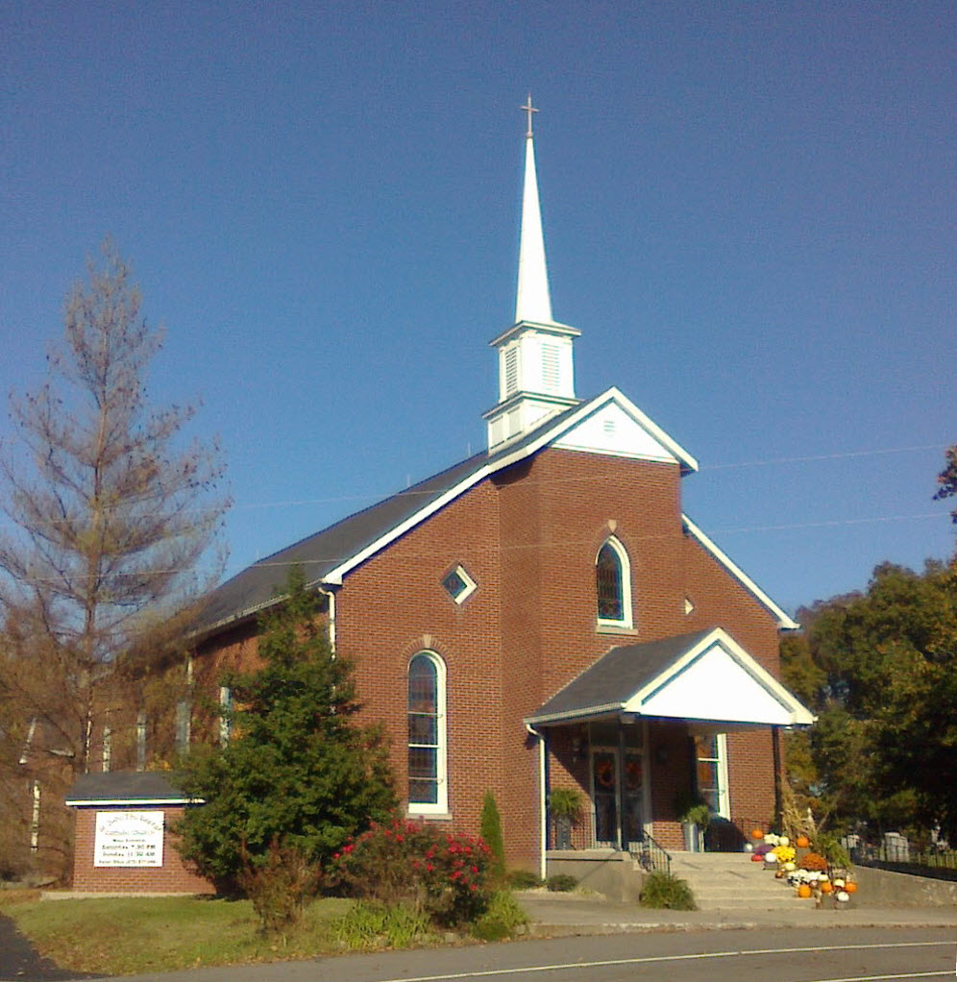

**Pastor:**

***Rev. Daniel L. Lincoln***

Rectory: (270) 877-2546

**Deacon:**

***Michael A. Ryan***

(270) 272-6789

314 E. Main St. 657 St. John Church Rd.

Vine Grove, KY 40175 Elizabethtown, KY 42701

Clustered Parish Office: Clustered Parish Office:

(270) 877-2461 (270) 877-2461

**ANNOINTING OF THE SICK:**

Notify the parish office when a family member is hospitalized.

**BAPTISM:**

Contact the parish office for information about the required preparation class.

**BULLETIN:**

Information must be submitted in writing by note or email to the parish office **no later than 12:00 noon on Wednesdays** for the following weekend. When sending an email, please put “BULLETIN,” and the name of the parish the announcement is for, in the subject line.

**MARRIAGE:**

Contact Father at least 6 months prior to the wedding date to complete required marriage preparations and to schedule the date.

**RCIA (Rite of Christian Initiation of Adults):**

Contact the Worship Chairperson for information.

**DEW MEMORIAL LIBRARY:**

(in St. Brigid Church basement):

Open: Sunday after 9:30 a.m. Mass& 45 minutes before all other Masses.

Email: [brigidvg@bbtel.com](mailto:brigidvg@bbtel.com) **Dir. of Religious Education:**

Website: [www.stbrigidvg.org](http://www.stbrigidvg.org)Lisa Thomas: (270) 735-6930

**Pastoral Associate & Dir. Youth Ministers:**

**of Religious Education:** Angela Churchman:

Deacon Mike Ryan: (270) 877-0546 (270) 268-9963

**Youth Minister:** Ericka Finlay: (502) 612-2644

Lori Law: (270) 723-0157

**MASS SCHEDULE:**

*Saturday (Vigil):*  6:30 p.m.

*Sunday:* 11:30 a.m.

*Wednesday:* 6:30 p.m.

*Friday:* 9:00 a.m.

**RECONCILIATION:**

Saturday before Mass

5:30-6:00p.m. or by appt.

**PARISH COUNCIL MEMBERS:**

*President:* Lauran Thomas

*Secretary:* Theresa Smith

**CHAIRPERSONS:**

*Administration:*  Nick Thomas

*Formation:* Ericka Finlay

*Parish Life:* Bradley Wickersham

*Worship:* Greg Thompson



**MASS SCHEDULE:**

*Sunday:* 9:30 a.m. & 6:30 p.m.

*Monday:* 9:00 a.m.

*Thursday:* 9:00 a.m.

**RECONCILIATION:**

Sunday before Mass

5:30-6:00 p.m. or by appt.

**ROSARY:**

After weekday Masses

**PARISH COUNCIL MEMBERS:**

*President:* Sue Weisshaupt

*Vice-President:* Mike Bramlett

*Secretary:* Judy Cochran

*At-Large Members:* Blake Ryan

& Vincent Thompson

**CHAIRPERSONS:**

*Administration:* Dale Winchester

*Formation:* Tina Yates

*Parish Life:* Tom Billings

*Worship:* Keith Baughman

**Mass Schedule**



|  |  |  |  |  |  |
| --- | --- | --- | --- | --- | --- |
| **Saturday** | **September 29** | **6:30 p.m.** | **St. John** | **For All Parishioners** | **Vigil: 26th Sunday in Ordinary Time** |
| **Sunday** | **September 30** | **9:30 a.m.** | **St. Brigid** | **Don Rogers**  **Helen C. Adams** | **26th Sunday in Ordinary Time** |
| **“** | **“** | **11:30 a.m.** | **St. John** | **Fr. Stan Osborne** | **“** |
| **“** | **“** | **6:30 p.m.** | **St. Brigid** | **Our Parish Family**  **Mae Wooldridge** | **“** |
| **Monday** | **October 1** | **9:00 a.m.** | **St. Brigid** | **Albert & Thelma Jenkins**  **Dorothy Hulsman** | **St. Therese of the Child Jesus, Virgin & Doctor of the Church** |
| **Wednesday** | **October 3** | **6:30 p.m.** | **St. John** | **Rose Marie Yates** | **Weekday** |
| **Thursday** | **October 4** | **9:00 a.m.** | **St. Brigid** | **Harold Yates**  **Rose Marie Yates** | **St. Francis of Assisi** |
| **Friday** | **October 5** | **9:00 a.m.** | **St. John** | **Bruce & Margaret Lincoln** | **Weekday** |
| **Saturday** | **October 6** | **6:30 p.m.** | **St. John** | **For All Parishioners** | **Vigil: 27th Sunday in Ordinary Time** |
| **Sunday** | **October 7** | **9:30 a.m.** | **St. Brigid** | **Our Parish Family**  **Carlos Robbins** | **27th Sunday in Ordinary Time** |
| **“** | **“** | **11:30 a.m.** | **St. John** | **Brad French** | **“** |
| **“** | “ | **6:30 p.m.** | **St. Brigid** | **Billie Cecil**  **Dickie Cecil** | **“** |

**For Both Parishes**

**VOCATIONS** – Do you know a young man or woman who might make a great priest, brother or sister? Help the Archdiocese of Louisville Vocations Office connect with them! By submitting names through our Called by Name initiative, you'll help us send potential discerners good information and invitations to discernment events. To participate visit: [www.louisvillevocations.com/called-by-name/](http://www.louisvillevocations.com/called-by-name/)

**PYX** – If anyone has a pyx they are no longer using, please turn them in to Father Dan. They are needed for the hospital ministers.

**ABORTION AND ADOPTION –** The number of would-be adoptive parents (of newborn babies) far outstrips the supply in America. Each year in the United States, about 135,000 American children are placed for adoption. Experts estimate somewhere between one and two million couples seek to adopt yearly. Every year, there are about 1.3 million abortions. Sadly, only 4% of women with unwanted pregnancies give their children up for adoption. Every child is wanted and wanted desperately! By Pro-Life Articles Author [www.pro-lifearticles.org](http://www.pro-lifearticles.org)

**PROJECT RACHEL** **–** Healing…Forgiveness…Hope…After the experience of an abortion. If you or someone you know is struggling with the pain from an abortion, please consider Project Rachel – a post abortion ministry. To speak to someone confidentially, call (502) 471-2155 or email [ProjectRachel@archlou.org](mailto:ProjectRachel@archlou.org).

**CONFIDENTIAL PREGNANCY AND ADOPTION COUNSELING** – is available at Catholic Charities for women of all ages experiencing untimely pregnancies. A full range of services are provided, including adoptive placement, legal assistance and counseling for individuals, groups and families. Post-abortion counseling is also available. Services are provided regardless of income or marital status. For more information, call Catholic Charities at (502) 637-9786.

**WEDDING ANNIVERSARY MASS** – Archbishop Joseph Kurtz warmly invites couples celebrating their 30, 40, 50, 60 & 60 plus years wedding anniversary in 2018 to join others in the Archdiocese for a Mass of Thanksgiving at the Cathedral of the Assumption, 433 S. Fifth Street, Louisville, on **Sunday, October 21, at 2:00 p.m.** Family members are also invited to the celebration. Each couple will receive a certificate commemorating the occasion. Registration is required. Call the parish office to **register before Friday, October 5.**

**ST. THERESA (RHODELIA) BI-CENTENNITAL – Father George Illikkal and the parishioners of St. Theresa of Avila Church invite you to come celebrate 200 years of faith in Rhodelia, Kentucky on Sunday, October 14, 2018. Archbishop Joseph Kurtz will celebrate Mass at 10:30 a.m. followed by a reception in the Meade-Breck Center/Matt Pike Memorial Gym. Please RSVP by September 22, 2018 with your name and how many will be attending by email:** [**sttheresa@bbtel.com**](mailto:sttheresa@bbtel.com) **or via website: sttheresarhodelia.org or phone: 270-496-4362.**

**St. John and St. Brigid Prayer List**

To add someone to the prayer list, please call the parish office at (270) 877-2461. **Remember to call to remove someone from the list if they are no longer sick, etc.** *Please note that the prayer list has been revised. It is primarily for parishioners and their immediate family members*.

Leslie **Adams-Cerniglia**, Sam **Adams**, April **Allen**, Dennis **Arnold**, Barbara **Ashley**, Donnie Alan **Atcher**, Sue **Banks**, Shannon **Barnes,** Denise **Barnett**, Timothy **Birch**, Teresa **Blaycock**, Charlie **Bowers**, Pauline **Brangers**, Ellen **Bryan**, Richard **Bryson**, Carol **Buchanan**, Linda **Buchanan**, Jeremy & Margie **Buyer**, Deacon Bob **Caspar**, Sue **Caswell**, Ed **Cecil**, J. Mack **Cecil**, Steve **Cecil**, Harlan Ford **Clark**, Judy **Cleaver**, John **Connor**, Betty Jo **Cooper**, Heidi **Correa**, Jeff **Craig**, Glynn **Clutches**, Roan **Dowell**, Karen **Dworshak**, Leroy **Embry**, Marion **French**, Martha **Ford**, Dwayne **Garcia**, Carrie **Gribben**, Mary **Hager**, Mrs. Charles **Hair**, Stephanie **Hall**, Donnie **Hart**, Jimmy **Harper**, Bobby **Harris**, Eileen **Heinen**, Debbie **Hodge**, Betty Lou **Jones**, Charlene **Langley**, Olivia **Leasor**, Jenny **Leonhardt**, Jackie **Long**, Louise **Lucous**, Alma **Mahanna**, Shelly **Martin**, Shirley **Martin**, Martina **Masoni**, Don **Mattingly**, Gerard **Mattingly**, Paul Michael **Mattingly**, Mary **Medley,** Cindy **Miller**, Starla **Miller**, Doug **Osborne**, Duane **Osborne**, Mickey **Padgett**, Frank **Inanely**, Jerry **Phillips**, Annie **Pierce**, Adrianna **Porter**, Jeremy **Porter**, Adrian **Ray**, Allie **Ray**, Mary Agnes **Ray**, Mary Ellen **Ray**, Tonya **Reisinger**, Joel **Rivera**, Lelia Rose **Ryan**, Pat **Ryan**, Caroline **Seabee**, Leon **Skeeters**, Jim **Smith**, Ralph **Staples**, Keith **Tassin**, Anthony **Thomas**, Kenny **Thompson**, Raffaella **Tucker**, Debi **Turner**, Stacey **Vance**, Bill **Waldrop**, Lois **Weaver**, De Neil **Whelan**, Paul A. **Whelan**, Jennifer **Williams**, Sandy **Wiseman**, Zach **Wiseman**, Gail **Wilson**, Don **Wooldridge**, Connor **Wright**, and all the sick, both mentally and physically.

**OUR MILITARY List**

To add someone to the military list, please call the parish office at (270) 877-2461. **Remember to call to remove someone from the list if they are no longer in the service**.

Lt. Matt **Bednar**, PFC Richard H. **Chapman**, A1C Aaron **Chandler**, A1C Brandon **Davila**, SrA Felicia **Esquivel**, PFC Tyler **Hall**, A1C Ryan **Henley**, A1C Joseph **Manco**, SPC Jacob L. **Nall**, SFC Peter **Novak**, Tony **Rickerl**, James **Rogers**, Tony **Rogers**, Jonathon **Sifford**, Jeffrey **Slade**, Derek **Smith**, CSM Vance **Snider**, Brian **Tomassi**, A1C Daniel **Trombone**, SGT Evan **Vaughan**, PV2 William **Vaughan**, Lisa **Flynn-Veri**, LT Michael **Veri**, LTC Steve **Wickersham**, SGT Clay **Wilson**, TSGT Jeremy **Yates**, Austin **Zulka** and for all who serve and have served our country.

**St. John The Baptist catholic church**

**Monthly Budget Amount Needed:** $ 12,500.00

**Monthly Collection for August:** $ 12,250.00

**Monthly Collection for September**  $ 10,468.00

**WELCOME PACKETS** – If you would like to become a member, or learn more about St. John Parish, please take a *Welcome Packet* in the church lobby. You may return the census card and the stewardship form to Father Dan or place in the collection basket.

**CATHOLIC SERVICES APPEAL 2018** – Our financial goal this year is $21,900. Our participation goal is 96 families. Let us respond promptly and generously this year.

9

**REST IN PEACE** – Please keep the family of Bill “Red” French, who died last week, in your prayers. May he rest in peace.

**PARISH PICNIC POTLUCK** – Thanks to all who organized, worked at and participated in our annual picnic. It was a day of good food, fellowship and fun!

**DISCERNMENT CORE TEAM UPDATE** – We are continuing to work on implementing many of the suggestions that were discussed in the small group gatherings.  Our Facebook page is up and running thanks to Kolbe Disselkamp and Dana Ingram.  Hannah Thomas is working on a web page for the Church.  Our hope is that these two items alone will help to keep everyone more informed about happenings in our parish.  As of August 1, all stewardship lists have been updated and in place.  If you haven't completed a stewardship form they are still available, ask Father or one of the Core Team members.  If you don't see your name appear over the next few months in one of the Mass roles that you wanted to participate in, please reach out to the Core Team and we will make sure that your information is updated.  Over the next several months we will be coordinating meetings for all new committees so that everyone has a chance to participate.  Some committees may only meet once or twice a year, but please try to attend these meetings so that your gifts of time, talent and treasure can be shared with our parish.  Any questions can be directed to one of the Core Team Members:  Clarissa Yates, Rick Newton, Rhonda Newton, Karen Ray, Ericka Finley, Lisa Thomas.

**ST. JOHN PARISH SHIRTS ORDER** - will be placed **Monday, October 15,** if you wish you purchase a shirt, please pay Aimee Hunt after Mass on Sunday, October 7, or Saturday, October 13. Payment for shirts is due no later than October 15. If you have any questions, feel free to contact Aimee Hunt via Facebook, or text at (270) 268-6411. Prices are as follows:

Short Sleeve: No charge

Long Sleeve: $25.00 adult; $20.00 youth

Sweat Shirt (no hood): $35.00 adult;

$20:00 youth

Short sleeve shirts will be heather orange with royal blue writing, as seen at the picnic, and long sleeves and sweat shirts will be the opposite - blue shirt and orange writing.

**RELIGIOUS EDUCATION –** We are off to a good start this year.  There are still a few faces we have not seen and are looking forward to joining us.  Classes are every Sunday from 9:45 to 11:00 a.m. for 3-year-old preschool through high school.  **NO CLASS ON SEPTEMBER 30 DUE TO FALL BREAK. CLASSES WILL RESUME ON OCTOBER 7.** Remember, this is the most important team you can be on. Make RE class an important family priority with good attendance.

**SAFE ENVIRONMENT TRAINING –** We have scheduled a Safe Environment Training workshop for **Monday, November 12 at 6:30 p.m.**  in the Parish Hall.  This training is required for anyone volunteering with our VBS or Religious Education Program.  Training is a one-time requirement and lasts no longer than 1 to 1-1/2 hours.  Any questions please contact Lisa Thomas (270) 735-6930 or [glalt@comcast.net](mailto:glalt@comcast.net)

**St. John liturgical ministers**

|  |  |
| --- | --- |
| **Vigil: 27th Sunday in Ordinary Time, October 6, 2018** | **6:30 p.m.** |
| Extraordinary Ministers of the Eucharist | Joanna Sherrard Lori Shinault Amy Thomas |
| Lector | Lori Shinault |
| Servers | Claire Thomas Drew Thomas |
| Greeter(s) | Angela Churchman |
| Gift Bearers | Givan Family |
| - Ushers | John Thomas Zach Thomas |
| **27th Sunday in Ordinary Time, October 7, 2018** |  |
| Extraordinary Ministers of the Eucharist | Angela Thompson Jennifer Updegraff Jose Resto-Vargas |
| Lector | Amanda Quiggins |
| Servers | Ben Updegraff Jose Resto-Santos |
| Greeter(s) | Lisette Resto-Santos |
| Gift Bearers | Sandi & Steve Brangers |
| Ushers | Brandon Wiseman Trent Thomas |
| **Hospital Ministry – Sunday, October 28, 2018** | Martha Thomas & Lauran Thomas |

**St. Brigid catholic church**

**Monthly Budget Amount Needed:** $ 25,280.00

**Monthly Collection for August:** $ 26,287.59

**Monthly Collection for September:** $ 24,321.00

**WELCOME VISITORS** – If you are interested in joining our parish, please pick up a Welcome Packet at the church doors. Complete the registration form and either drop it in the collection basket or mail it to the office. If you just need to update your registration, there are also forms available.

**CATHOLIC SERVICES APPEAL 2018** – Our financial goal this year is $35,500. Our participation goal is 129 families. Let us respond promptly and generously this year.

**THANK YOU!** to Gina Ryan and Teresa Morgan, for chairing the Summer Event, to Darlene Staples and Mike Ryan for keeping track of the tickets and required paperwork, to the Osterhage family for taking care of the Cake Wheel, to *Two Taylors Catering* for preparing a wonderful meal, to all the kitchen help and the youth for taking care of bussing tables and taking care of drinks and also for taking care of games, face painting, crafts. Special thanks to Verland Hatmaker and the Gang of 3 guys and a gal for providing wonderful entertainment and great music and also all who purchased Summer Event tickets. We sold all 300 tickets by 3:00 p.m. Thanks also to all who provided silent auction items and purchased silent auction items (we had 49 items, the most ever), and for all who provided desserts for the dinner and for the cakes and pies for the cake wheel. Special thanks for our religious education youth and Lori Law, who helped: Andrew Thompson, Morelia Falcon, Michael Mayes, Jaden Hicks, Breanna Davison, Thomas Webb, Molly New, Caroline New, Tyler Arrigo, Michael Rowe, Kacie Ray, Christopher Morgan, Nathaniel Morgan, Gabe Russell, David Webb, Thomas Webb, Kelsey Adkins and Martine Rogers. Thanks also to helpers Danielle & Blake Ryan and Pat & Sam Wood. Special thanks to Fr. Dan Lincoln for all his support.

**CONGRATULATIONS!** Summer Event Winners were our very own 4th Degree Knights of Columbus Council. They put their name on it and St. Brigid Parish who each won $5,000.00 tax free.  The quilt winner was our very own Alice Moss. The Altar Society and Janice Jenkins sold over 1700 quilt tickets.

**EXTRAORDINARY MINISTERS OF THE EUCHARIST** – October through December 2018 EM schedules may be picked up at the back of the church. Thank you for your continued service.

**ST. VINCENT DE PAUL SOCIETY** – Because of tax law changes all donations to SVDP should be made out to St. Vincent de Paul NOT to St. Brigid Church. Your donation is still tax deductible. THANK YOU for your continued support of SVDP to help the local poor and needy.

**BASKETBALL PROGRAM** – Basketball will not begin until October, so we will post sign-up sheets in August. So far, we have had one adult offer to coach and one adult offer to coach and play in an adult league.

**FROM THE LIBRARY** – **>** There is now an Accelerated Reader section in the library.  Books are labeled by grade level K-8.  Please read and return the book to the correct tub.  Good luck on your testing at school! **>** There is a High School reading section geared toward college bound.  Read and return. **>** Four tables are full of free adult reading.  Read and pass along. **>** The kid table is full of books to be read and returned.  Many new choices. > The large circle table is now a Genealogy resource.  Books need to be checked out and returned. **>** Dr. Dew’s library is still intact.  Read and return where you got them. **>** Thanks to those who have donated books for all to enjoy!

**POWER IN MY HANDS** – October is the month of the rosary. Next week on **Sunday, September 30,** after Mass, the DRE, Knights of Columbus 4th Degree, and Our Lady’s Rosary Makers will be showing the movie, *Power in My Hands*, which was shown in select theaters across America. This revolutionary, feature-length documentary introduces the world to the beauty, timelessness, and power of the rosary through shared stories of ordinary families and individuals who have experienced miracles as a result of their devotion to this form of prayer. *Power in My Hands* seeks to revitalize America – a society in spiritual crisis and demonstrate the power of praying the rosary. This film will speak to your heart and will be a useful for teachers and catechists, yet it is engaging enough for a family movie night.

**YOUNG AT HEART** – will meet **Wednesday, October 3**, for a pot luck dinner. Games will start at 11:00 a.m. The pot luck dinner will start at 12:00 noon. The parish provides the chicken. Please bring a friend.

**31ST ANNUAL NATIONAL LIFE CHAIN** – Please save the date! Right to Life Kentucky Heartland, the local affiliate of Kentucky Right to Life, invites everyone to participate in the local chain of the 31st Annual National Life Chain on **Respect Life Sunday, October 7, from 2:30-3:30 p.m.** Participants will stand on the public sidewalk holding pro-life signs provided by the affiliate and pray silently for an end to abortion in our country. The distribution site for signs for St. Brigid is the parking lot on Walmart Way behind Stithton Baptist Church in Radcliff. Please arrive early to choose a sign and get in place. POC: Betty Rose Jones, (270) 877-5508.

**BLOOD DRIVE** – The next blood drive will be held on **Friday, October 12, from 10:00 a.m. to 2:00 p.m.** in the CCC.

**St. Brigid youth ministry**

**Wednesday, October 3-4:** - **Lock-in to Lock-out Hunger -** All 8th-12th grade youth are invited to participate in this lock-in that will take place in the CCC from 8:00 p.m. Wednesday until 8:00 a.m. Thursday. The cost is $5.00 per youth and all proceeds will go to Plowshare Farms as they help feed the hungry in our state. Please RSVP to Lori by Tuesday if you plan to attend. All those who RSVP will receive a text on what to bring and a reminder.

**Wednesday, October 10** - Youth Open Gym in the CCC for all 8th-12th graders from 6:30-8:30 p.m. Our new year of youth group is just getting started, if you have never come to open gym or other youth events in the past now is a good time to get started.

If you have any questions, please contact Lori at (270) 723-0157 or email at [stbrigidyouth@hotmail.com](mailto:stbrigidyouth@hotmail.com).

**St. Brigid monthly meet and greet**

St. Brigid Parish hosts a “Meet and Greet” downstairs the 2nd Sunday of each month immediately following the 9:30 a.m. Mass with coffee and donuts. This is a great opportunity for existing parishioners to extend a warm welcome to visitors and anyone interested in joining St. Brigid Parish. Be sure to also visit the Dew Memorial Library.

**The next Meet and Greet will be Sunday, October 14, 2018.**

|  |  |
| --- | --- |
| **27th Sunday in Ordinary Time, October 7, 2018** | **9:30 a.m.** |
| Extraordinary Ministers of the Eucharist P. | Angie Bragg Paula Greenwell |
| C. | Helen Hicks Gary Morris David Stoddard Rose Cooper  **St. Brigid liturgical ministers** |
| Lector | Mark Kelly |
| Servers | David Webb Gabe Russell |
| Greeters | Dennis Bower Dale & Mary Winchester |
| **27th Sunday in Ordinary Time, October 7, 2018** | **6:30 p.m.** |
| Extraordinary Ministers of the Eucharist P. | Keith Baughman |
| C. | Ken Spangenberger Ron Masoni |
| Lector | Ron Masoni |
| Servers | Volunteers |
| Greeters | Volunteers |
| **Hospital Ministry – Sunday, October 14, 2018** | Ralph and Sherleen Barren |

**St. Brigid faith formation news**

**FAITH FORMATION NEWS**

**THE CANDY BANK IS OPEN!**

* Make your deposits NOW of individually wrapped Halloween candy at the front of the church.
* Help us cover the cost of the hundreds of trick or treaters at this year’s Trunk or Treat!!

Questions? Call Selina Chandler at (270) 765-3672.

